ЭТАПЫ ВЫПОЛНЕНИЯ

**Этапы выполнения:**

1. Создание подключения к серверу;

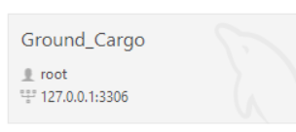

1. Создание файла БД;



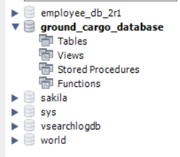

1. Реализация таблиц в соответствии со словарём данных;

| Ключ | Наименование | Тип данных | Примечание | Скрипт MySQL |
| --- | --- | --- | --- | --- |
| Client | | | | |
| PK | ID_Client | Int | Первичный ключ таблицы Заказчик | CREATE TABLE Client(      ID_Client int not null auto_increment PRIMARY KEY,      Client_Organization_Name varchar(100) not null,      Client_Legal_Address varchar(100) null DEFAULT '-',      Client_Physical_Address varchar(100) not null,      Client_ITN varchar(11) not null UNIQUE constraint CH_Client_ITN           CHECK(regexp_like(Client_ITN, '[0-9]{10}')),      Client_BIC varchar(10) not null UNIQUE constraint CH_Client_BIC          CHECK(regexp_like(Client_BIC, '[0-9]{9}')) ,      Client_OKPO varchar(11) not null UNIQUE constraint CH_Client_OKPO          CHECK(regexp_like(Client_OKPO, '[0-9]{8}|[0-9]{10}')) ,      Client_Repr_Surname varchar(30) not null,      Client_Repr_Name varchar(30) not null,      Client_Repr_Second_Name varchar(30) null DEFAULT '-'  ); |
|  | Client_Organization_Name | Varchar(100) |  |
|  | Client_Legal_Address | Varchar(100) | Null |
|  | Client_Physical_Address | Varchar(100) |  |
|  | Client_ITN | Varchar(10) | Уникальное поле  0000000000 |
|  | Client_BIC | Varchar(9) | Уникальное поле 000000000 |
|  | Client_OKPO | Varchar(10) | Уникальное поле 00000000  Или  0000000000 |
|  | Client_Repr_Surname | Varchar(30) |  |
|  | Client_Repr_Name | Varchar(30) |  |
|  | Client_Repr_Second_Name | Varchar(30) | Null |
| Manager | | | | |
| PK | ID_Manager | Int | Первичный ключ таблицы менеджер по обработке заявок | CREATE TABLE Manager(      ID_Manager int not null auto_increment PRIMARY KEY,      Manager_Surname varchar(30) not null,      Manager_Name varchar(30) not null,      Manager_Second_Name varchar(30) null DEFAULT '-',      Manager_Passport_Series varchar(4) not null constraint CH_Manager_Passport_Series          CHECK(regexp_like(Manager_Passport_Series, '[0-9]{4}')),      Manager_Passport_Number varchar(6) not null constraint CH_Manager_Passport_Number          CHECK(regexp_like(Manager_Passport_Number, '[0-9]{6}')),      Manager_ITN varchar(10) not null UNIQUE constraint CH_Manager_ITN          CHECK(regexp_like(Manager_ITN, '[0-9]{10}')),      Manager_SNILS varchar(14) not null UNIQUE constraint CH_Manager_SNILS      CHECK(regexp_like(Manager_SNILS, '[0-9]{3}\\-[0-9]{3}\\-[0-9]{3} [0-9][0-9]'))  ); |
|  | Manager_Surname | Varchar(30) |  |
|  | Manager_Name | Varchar(30) |  |
|  | Manager_Second_Name | Varchar(30) | Null |
|  | Manager_Passport_Series | Varchar(4) | 0000 |
|  | Manager_Passport_Number | Varchar(6) | 000000 |
|  | Manager_ITN | Varchar(10) | Уникальное поле  0000000000 |
|  | Manager_SNILS | Varchar(14) | Уникальное поле  000-000-000 00 |
| Driver | | | | |
| PK | ID_Driver | Int | Первичный ключ таблицы водитель | CREATE TABLE Driver(      ID_Driver int not null auto_increment PRIMARY KEY,      Driver_Surname varchar(30) not null,      Driver_Name varchar(30) not null,      Driver_Second_Name varchar(30) null DEFAULT '-',      Driver_Passport_Series varchar(4) not null constraint CH_Driver_Passport_Series          CHECK(regexp_like(Driver_Passport_Series, '[0-9]{4}')),      Driver_Passport_Number varchar(6) not null constraint CH_Driver_Passport_Number      CHECK(regexp_like(Driver_Passport_Number, '[0-9]{6}')),      Driver_SNILS varchar(14) not null UNIQUE constraint CH_Driver_SNILS      CHECK(regexp_like(Driver_SNILS, '[0-9]{3}\\-[0-9]{3}\\-[0-9]{3} [0-9][0-9]')),      Driver_FFOMI varchar(16) not null UNIQUE constraint CH_Driver_FFOMI      CHECK(regexp_like(Driver_FFOMI, '[0-9]{16}')),      Driver_License_Series varchar(4) not null constraint CH_Driver_License_Series      CHECK(regexp_like(Driver_License_Series, '[0-9]{4}')),      Driver_License_Number varchar(6) not null constraint CH_Driver_License_Number      CHECK(regexp_like(Driver_License_Number, '[0-9]{6}'))  ); |
|  | Driver_Surname | Varchar(30) |  |
|  | Driver_Name | Varchar(30) |  |
|  | Driver_Second_Name | Varchar(30) | NULL |
|  | Driver_Passport_Series | Varchar(4) | 0000 |
|  | Driver_Passport_Number | Varchar(6) | 000000 |
|  | Driver_SNILS | Varchar(14) | Уникальное поле  000-000-000 00 |
|  | Driver_FFOMI | Varchar(16) | Уникальное поле  0000000000000000 |
|  | Driver_License_Series | Varchar(4) | 0000 |
|  | Driver_License_Number | Varchar(6) | 000000 |
| Vehicle | | | | |
| PK | ID_Vehicle | Int | Первичный ключ таблицы Автотранспорт | CREATE TABLE Vehicle  (              ID_Vehicle int not null auto_increment PRIMARY KEY,              Vehicle_Width int not null,              Vehicle_Height int not null,          Vehicle_Length int not null,          Vehicle_Capacity int not null,          Vehicle_State_Number varchar(10) not null constraint CH_Vehicle_State_Number      CHECK(regexp_like(Vehicle_State_Number, '[А-Я]{2}[0-9]{3}[А-Я] [0-9]{2,3}'))  ); |
|  | Vehicle_Width | Int | Ширина в сантиметрах |
|  | Vehicle_Height | Int | Высота в сантиметрах |
|  | Vehicle_Length | Int | Длина в сантиметрах |
|  | Vehicle_Capacity | Int | Грузоподъёмность в килограммах |
|  | Vechicle_State_Number | Varchar(10) | AA000A 999 |
| Complexity | | | | |
| PK | ID_Complexity | Int | Первичный ключ таблицы сложность | CREATE TABLE Complexity  (              ID_Complexity int not null auto_increment PRIMARY KEY,              Complexity_Level int not null UNIQUE  ); |
|  | Complexity_Level | Int | Значения – 1,2,3 |
| Request | | | | |
| PK | ID_Request | Int | Первичный ключ таблицы Заявка | CREATE TABLE Request(      ID_Request int not null auto_increment PRIMARY KEY,      Request_Number int not null,      Manager_ID int not null REFERENCES Manager (ID_Manager),      Client_ID int not null REFERENCES Client (ID_Client),      Request_Date date null DEFAULT(CURRENT_DATE),      Request_Time TIME null DEFAULT(CURRENT_TIMESTAMP)  ); |
|  | Request_Number | Int | Порядковый номер заявки |
| FK | Manager_ID | Int |  |
| FK | Client_ID | Int |  |
|  | Request_Date | Date | Дата заявки |
|  | Request_Time | Time | Время заявки |
| Cargo | | | | |
| PK | ID_Cargo | Int | Первичный ключ таблицы Груз | CREATE TABLE Cargo(      ID_Cargo int not null auto_increment PRIMARY KEY,      Cargo_Description varchar(200) not null,      Request_ID int not null REFERENCES Request (ID_Request),      Cargo_Width int not null,      Cargo_Height int not null,      Cargo_Length int not null,      Cargo_Weight int not null,      Cargo_Price int null DEFAULT 0  ); |
|  | Cargo_Description | Varchar(200) |  |
| FK | Request_ID | Int |  |
|  | Cargo_Width | Int | Ширина в сантиметрах |
|  | Cargo_Height | Int | Высота в сантиметрах |
|  | Cargo_Length | Int | Длина в сантиметрах |
|  | Cargo_Weight | Int | Вес в кг |
|  | Cargo_Price | Int | NULL  Стоимость в рублях |
| Delivery_Point | | | | |
| PK | ID_Delivery_Point | Int | Первичный ключ таблицы Точка доставки | CREATE TABLE Delivery_Point(      ID_Delivery_Point int not null auto_increment PRIMARY KEY,      Delivery_Point_Mark varchar(1) null DEFAULT '-' constraint CH_Delivery_Point_Mark          CHECK(regexp_like(Delivery_Point_Mark, '[+]|[-]')),      Request_ID int not null REFERENCES Request (ID_Request),      Delivery_Point_Destination varchar(200) not null  ); |
|  | Delivery_Point_Mark | Varchar(1) | NULL  + - завершён  NULL – - незавершён |
| FK | Request_ID | Int |  |
|  | Delivery_Point_Destination | Varchar(MAX) | Адрес |
| Route_Sheet | | | | |
| PK | ID_Route_Sheet | Int | Первичный ключ таблицы Маршрутный лист | CREATE TABLE Route_Sheet(      ID_Route_Sheet int not null auto_increment PRIMARY KEY,      Route_Sheet_Number int not null,      Complexity_ID int not null REFERENCES Complexity (ID_Complexity),      Vehicle_ID int not null REFERENCES Vehicle (ID_Vehicle),      Driver_ID int not null REFERENCES Driver (ID_Driver),      Route_Sheet_Date Date null DEFAULT(CURRENT_TIMESTAMP)  ); |
|  | Route_Sheet_Number | Int | Порядковый номер маршрутного листа |
| FK | Complexity_ID | Int |  |
| FK | Vehicle_ID | Int |  |
| FK | Driver_ID | Int |  |
|  | Route_Sheet_Date | Date |  |
|  |  |  |  |  |
| Combination_Route_Sheet_Delivery_Point | | | | |
| PK | ID_Combination_Route_Sheet_Delivery_Point | Int | Первичный ключ таблицы Совместительство маршрутный лист + точка доставки | CREATE TABLE Combination_Route_Sheet_Delivery_Point(      ID_Combination_Route_Sheet_Delivery_Point int not null auto_increment PRIMARY KEY,      Route_Sheet_ID int not null REFERENCES Route_Sheet (ID_Route_Sheet),      Delivery_Point_ID int not null REFERENCES Delivery_Point (ID_Delivery_Point)  ); |
| FK | Route_Sheet_ID | Int |  |
| FK | Delivery_Point_ID | Int |  |
| Combination_Route_Sheet_Cargo | | | | |
| PK | ID_Combination_Route_Sheet_Cargo | Int | Первичный ключ таблицы Совместительство маршрутный лист + груз | CREATE TABLE Combination_Route_Sheet_Cargo(      ID_Combination_Route_Sheet_Cargo int not null auto_increment PRIMARY KEY,      Route_Sheet_ID int not null REFERENCES Route_Sheet (ID_Route_Sheet),      Cargo_ID int not null REFERENCES Cargo (ID_Cargo)  ); |
| FK | Route_Sheet_ID | Int |  |
| FK | Cargo_ID | Int |  |

1. Демонстрация древа объектов БД.

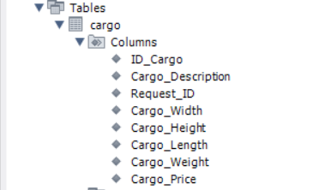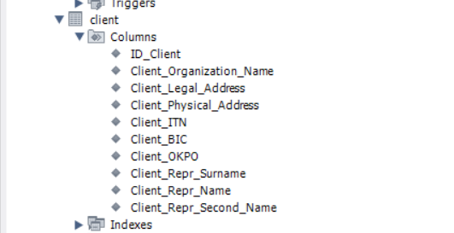

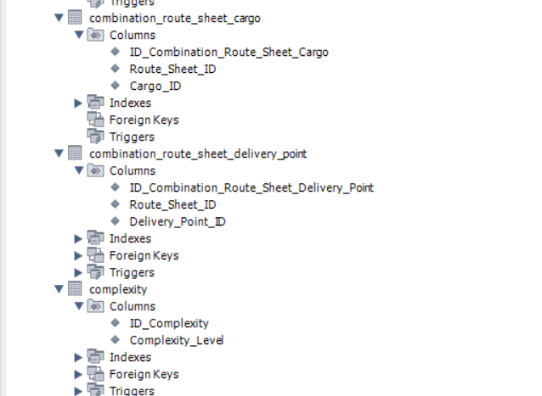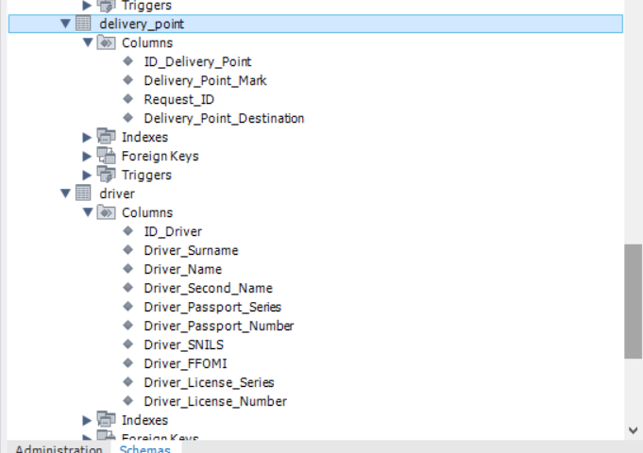

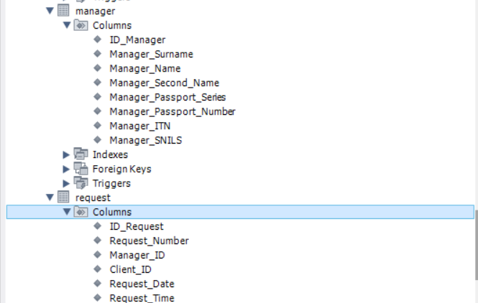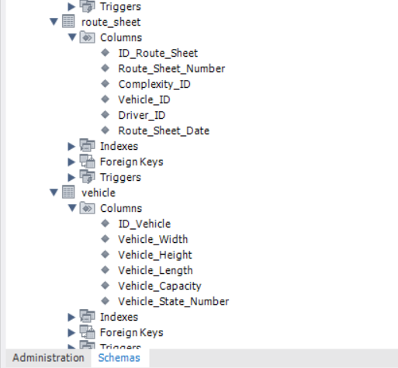

1. Отчёт о количестве таблиц;

SELECT count(*) FROM information_schema.tables

where table_schema = 'sale_product_database' and table_type = 'BASE TABLE';

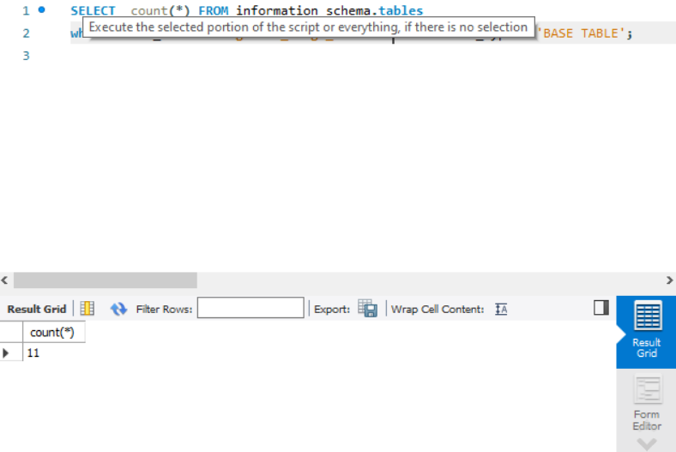

1. Отчёт о количестве столбцов в таблицах.

SELECT table_name, count(column_Name) FROM information_schema.columns

where table_schema = 'sale_product_database'

group by table_name;

